Transaction Move Order

**Oracle Support** [Requested Quantity With Decimals Is Rounded When Allocate Item In Transact Move Order Form (Doc ID 1334540.1)](https://support.oracle.com/epmos/faces/DocumentDisplay?_afrLoop=502135234111644&id=1512071.1&_afrWindowMode=0&_adf.ctrl-state=mp79w2az2_4)

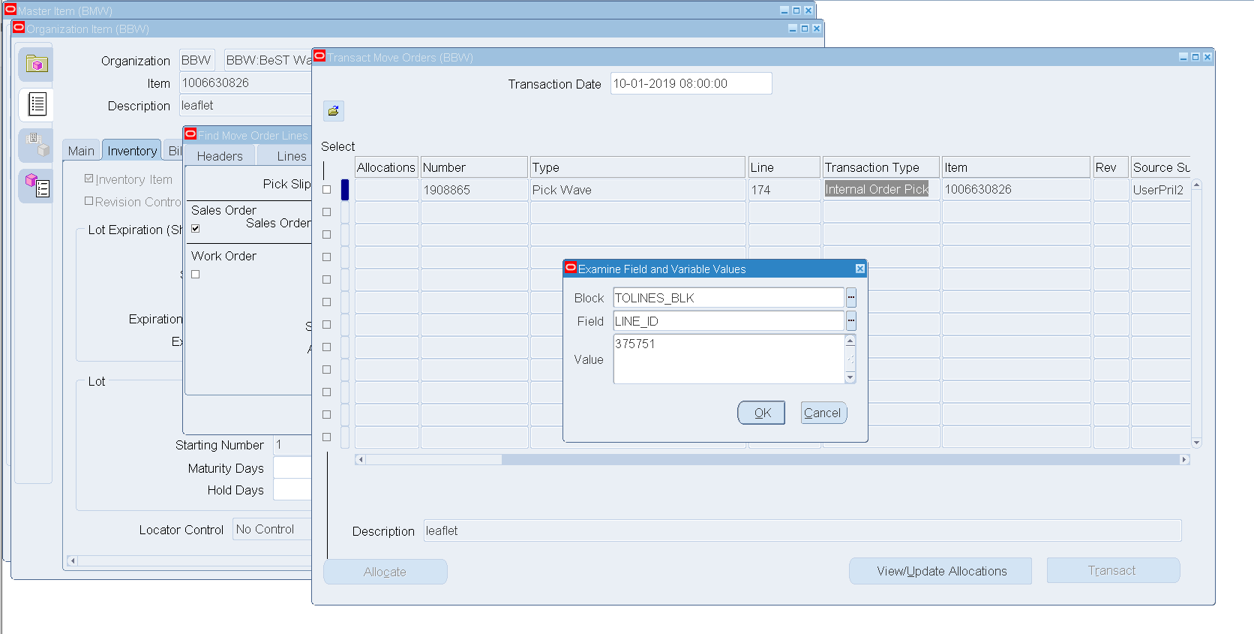

/* Проверка */

select c.header_id, c.line_id, c.PRIMARY_QUANTITY, c.quantity, c.quantity_detailed, c.*

from APPS.mtl_txn_request_lines c

where line_id = **375751**;

/* Formatted on 11.01.2019 9:30:11 (QP5 v5.318) Service Desk 267177 Mihail.Vasiljev */

UPDATE APPS.MTL_TXN_REQUEST_LINES

SET QUANTITY = **0.2**,

QUANTITY_DETAILED = **0.2**,

PRIMARY_QUANTITY = **0.2**,

SECONDARY_QUANTITY = **0.2**

WHERE line_id = **375751**;